# Data on NH3 emissions after surface application of separated liquid manure (slurry)

## Data

Data selection criteria:

* Measurements at the same time from untreated pig or cattle slurry or digested slurry and its liquid fraction after separation.
* The slurry must be surface applied, e.g. data where slurry has been incorporated (closed or open slots) has not been included.
* There has been no selection of data, so the dataset includes both field and laboratory measurements and all measurement techniques. This means that for some data points origin is a single measurement in laboratory with soil conditions far from field conditions and other data points originates from replicate measurements out in a field with e.g. wind tunnels or micrometeorological measurements.

In the excel sheet *literature* the first sheet has a list of the used literature. The list includes 22 peer reviewed articles, one manuscript in preparation and one report. In some cases the emission data is taken from figures, so these data is assumed to be subject to some uncertainty. In the excel sheet it is written where in the article/report the data is from.

Data from one of the peer review articles (Mattila et al. (2003)) is not included yet as several exeriments is averaged in the manuscript. The author has said he will provide the detailed data.

For Anderson et al. (in prep), Hjorth et al. (2009), Nyord et al. (2018), Pedersen et al. (2021a) and Wagner et al. (2021) emission factors has been provided by the authors, e.g. even though they are present as figures in the reports the emission factors are not taken from these and does not have the uncertainty mentioned above.

For Pedersen et al. (2021b) raw data from all four experiments is used, hence it is not the statistically modelled results that is presented in the paper that is included.

A total of 81 datapoints (reductions due to separation, so 81 emission factors for separated slurry and 81 emission factors for untreated slurry) was obtained. There is big variability in the data (Fig. 1) and there is a predominance of data from cattle slurry (50 data points), followed by pig slurry (21 data points), whereas there is only 8 and 2 data points for digested pig slurry and digestate, respectively. (Fig. 2a-b).

## Plots

Plots has been made based on the data in the data sheet *literature*, the data has been put into another data sheet *plot.dat* so it can be loaded into R.

The code for the plots is in *effect plots.R.*

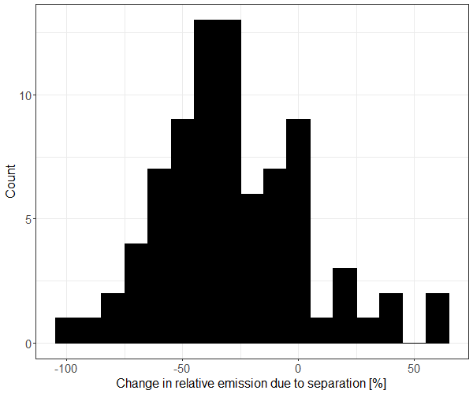

Fig. 1. Change in relative cumulative NH3 emission after field application of slurry due to separation. Histogram showing counts of data points within an interval.

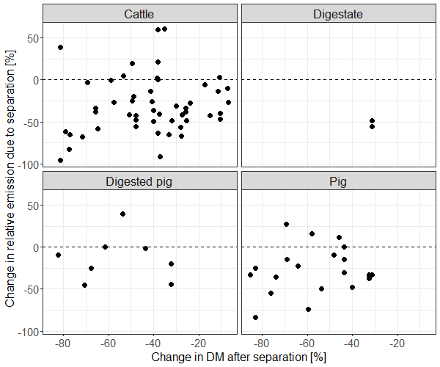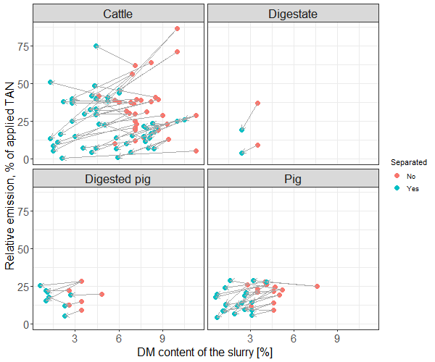

Fig. 2 a-b. Change in relative cumulative NH3 emission after field application of slurry due to separation relative to the reduction in dry matter.   
a: Negative values means that the cumulative NH3 of the separated slurry was reduced, whereas positive values means that it increased.   
b: points connected by arrows are from the same experiment.

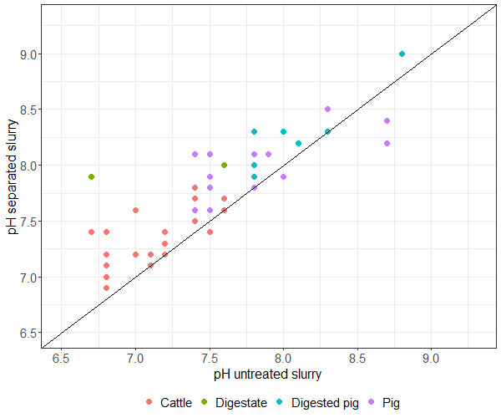

Fig. 3. pH of separated and untreated slurry.

## Some numbers

The average change in NH3 emission (all data included) after field application of separated manure is a reduction of 29±32%.

|  |  |  |  |  |  |  |  |  |  |
| --- | --- | --- | --- | --- | --- | --- | --- | --- | --- |
|  |  | Mean and standard deviation | | | | Median and range (minimum and maximum value) | | | |
| Separated | Slurry | DM | pH | TAN | Emission [% of applied TAN] | DM | pH | TAN | Emission [% of applied TAN] |
| No | Cattle | 8.5±1.7 | 7.3±0.3 | 2.5±0.9 | 33±19 | 8.7 (4.6-11.3) | 7.2 (6.7-7.8) | 2.8 (1-3.6) | 29 (5-87) |
| Digestate | 3.5 | 7.2±0.6 | 1.5 | 23±20 | 3.5 | 7.2 (6.7-7.6) | 1.5 | 23 (9-37) |
| Digested pig | 3.4±0.7 | 8.1±0.3 | 4.0±0.8 | 20±8 | 3.4 (2.6-4.8) | 8.1 (7.8-8.8) | 3.9 (3.3-5.6) | 21 (9-28) |
| Pig | 4.5±1.2 | 7.7±0.4 | 3.5±1.0 | 19±6 | 4.6 (2.8-7.6) | 7.5 (7.4-8.7) | 3.5 (2-5.4) | 22 (9-28) |
| All | 6.9±2.6 | 7.5±0.4 | 2.9±1.1 | 28±17 | 7.1 (2.6-11.3) | 7.5 (6.7-8.8) | 3.0 (1-5.6) | 25 (5-87) |
| Yes | Cattle | 5.1±2.5 | 7.4±0.3 | 2.4±1.0 | 23±16 | 4.5 (1.3-10.5) | 7.4 (6.9-8.1) | 2.7 (0.6-3.7) | 22 (0.2-75) |
| Digestate | 2.4 | 8.0±0.1 | 1.5 | 12±11 | 2.4 | 8.0 (7.9-8) | 1.5 | 12 (4-19) |
| Digested pig | 1.5±0.8 | 8.3±0.3 | 3.5±0.8 | 17±6 | 1.1 (0.6-2.7) | 8.3 (7.9-9) | 3.5 (2.5-4.7) | 18 (5-25) |
| Pig | 2.1±0.9 | 7.9±0.3 | 2.9±0.8 | 14±8 | 2.1 (0.6-4.1) | 7.8 (7.6-8.5) | 3.2 (1.5-5.1) | 12 (4-29) |
| All | 3.9±2.5 | 7.7±0.4 | 2.6±1.0 | 20±14 | 3.1 (0.6-10.5) | 7.7 (6.9-9.0) | 2.9 (0.6-5.1) | 18 (0.2-75) |

Table 1. Mean values ± standard variation and median with range of DM, pH, TAN and cumulative NH3 emission.